39th Annual Conference of the Australian and New Zealand Law and History Society, Auckland, 9th-12th December 2020

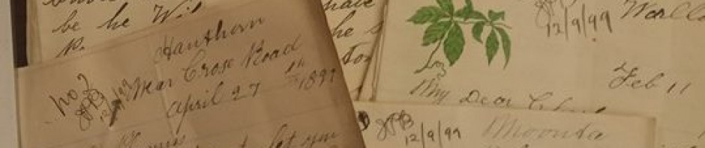Call for Papers

“One Empire, Many Colonies, Similar or Different Histories?”

Abstracts are invited from scholars bringing historical perspective on law who wish to gather at The University of Auckland and AUT University – there to listen to and discuss papers and panels on aspects of law in history. The 2020 theme invites a comparative lens on British imperial and colonial histories. Other papers with an historical perspective on law might include work that positions law in a specific temporal frame; deals with histories of law, lawmaking, and legal ideas; or has a focus on legal institutions and their personnel. Proposals from postgraduate and early career researchers are welcome.

Individual paper proposals for a 20 minute presentation must include an abstract (no more than 300 words) and a biographical statement (no more than 100 words).
Panel proposals by 3 or 4 speakers should include the above, plus a panel title and brief rationale for the panel as a whole (no more than 300 words).
All abstracts must be submitted to Karen Fairweather: k.fairweather@auckland.ac.nz by
15th July 2020

The Organising Committee intends to notify all those whose abstracts have been accepted for the programme by the end of August 2020. All presenters must be current financial members of the Australian and New Zealand Law and History Society, or must pay a subscription for the 2020 year.

Graduate students are invited to apply for Kercher Scholarships to assist them in attending the conference. Please apply to Katherine Sanders: k.sanders@auckland.ac.nz by 31 August. Graduate attendees may also wish to enter for the Forbes Society Prize.

The Society’s peer-reviewed journal law&history will consider submissions from those who present papers at the conference. A conference website with information on registration costs, accommodation options, etc will be established in due course. Our keynote speakers will include Dame Sian Elias (Retired NZ Chief Justice), Joshua Getzler (Oxford) and Miranda Johnson (Sydney, but soon to be at Otago).
A

Further information about the conference may be gleaned from David Williams:dv.williams@auckland.ac.nz or from https://anzlhs.org/

